**MUMBAI DABBAWALA PROJECT**

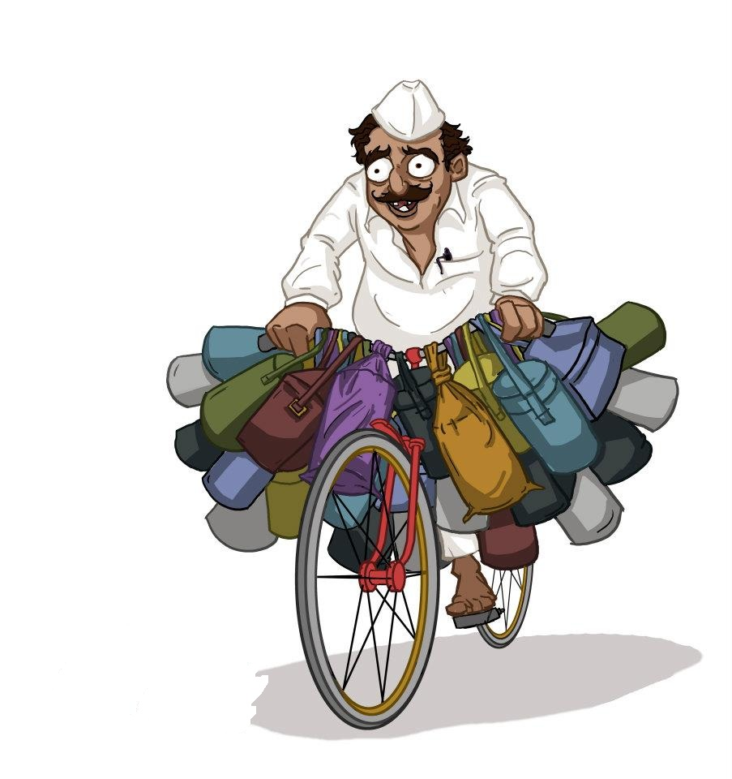

**PRESENTED BY:** NIKITA .M. MISTRY

**ROLL NO:** 3006

**TABLE OF CONTENTS:**

1. SYNOPSIS
2. INTRODUCTION
3. SYSTEM MODELS
4. E R DIAGRAM
5. DATAFLOW DIAGRAM
6. MODULES
7. SDLC WATERFALL MODEL
8. SYSTEM REQUIREMENTS
9. UML DIAGRAMS
10. DATABASE TABLES
11. SNAPSHOTS
12. CONCLUSION
13. REFERENCES
14. SAMPLE CODE

**-SYNOPSIS-**

In this document I am presenting the requirements specification for an online ordering system designed primarily for use in the food delivery industry. My system will allow restaurants to quickly and easily manage an online menu which customers can browse and use to place orders with just a few clicks. The system then relays these orders to restaurant employees through an easy to navigate graphical interface for efficient processing.

Described within the document is an overall model of the system, outlines of functional and non-functional requirements, and a detailed description of the user interface. Finally, the document presents an account of the evolution of the system along with anticipated maintenance.

**INTRODUCTION**

In today’s age of fast food and take-out, many restaurants have chosen to focus on quick preparation and speedy delivery of orders rather than offering a rich dining experience. Until very recently, all of these delivery orders were placed over the phone, but there are many disadvantages to this system, including the inconvenience of the customer needing to have a physical copy of the menu, lack of a visual confirmation that the order was placed correctly, and the necessity for the restaurant to have an employee answering the phone and taking orders.

The main advantage of my system is that it greatly simplifies the ordering process for both the customer and the restaurant. When the customer visits the ordering webpage, they are presented with an interactive and up-to-date menu, complete with all available options and dynamically adjusting prices based on the selected options. After making a selection, the item is then added to their order, which the customer can review the details of at any time before checking out. This provides instant visual confirmation of what was selected and ensures that items in the order are, in fact, what was intended.

This system also greatly lightens the load on the restaurant’s end, as the entire process of taking orders is automated. Once an order is placed on the webpage, it is entered into the database and then retrieved, in pretty much real-time, by a desktop application on the restaurant’s end.

# System Model

The structure of the system can be divided into three main logical components. The first component must provide some form of menu management, allowing the restaurant to control what can be ordered by customers. The second component is the web ordering system and provides the functionality for customers to place their order and supply all necessary details. The third and final logical component is the order retrieval system. Used by the restaurant to keep track of all orders which have been placed, this component takes care of retrieving and displaying order information, as well as updating orders which have already been processed.



**E R DIAGRAM:**

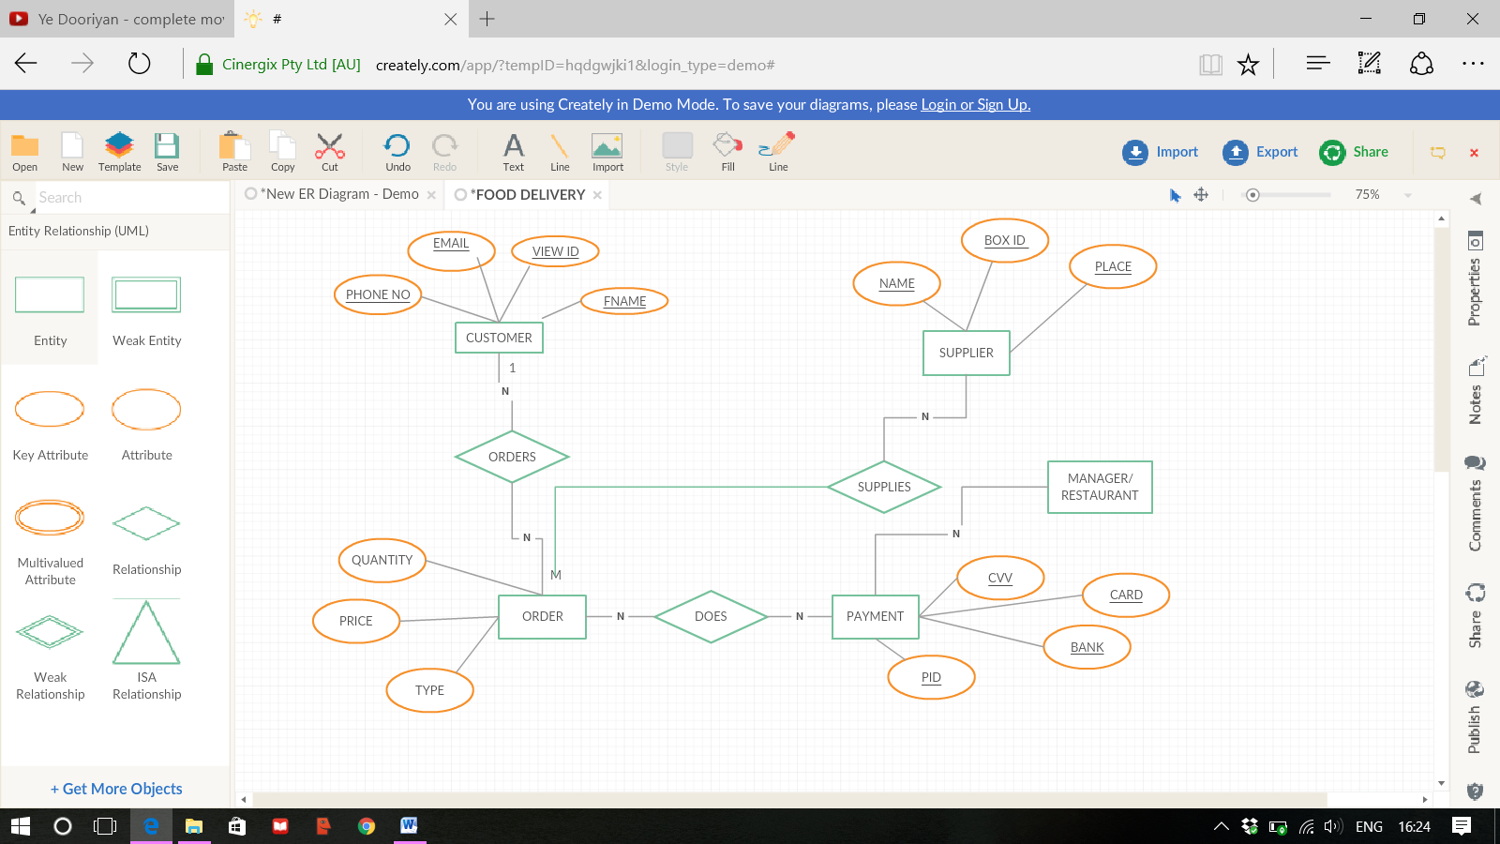

**DATA FLOW DIAGRAM:**

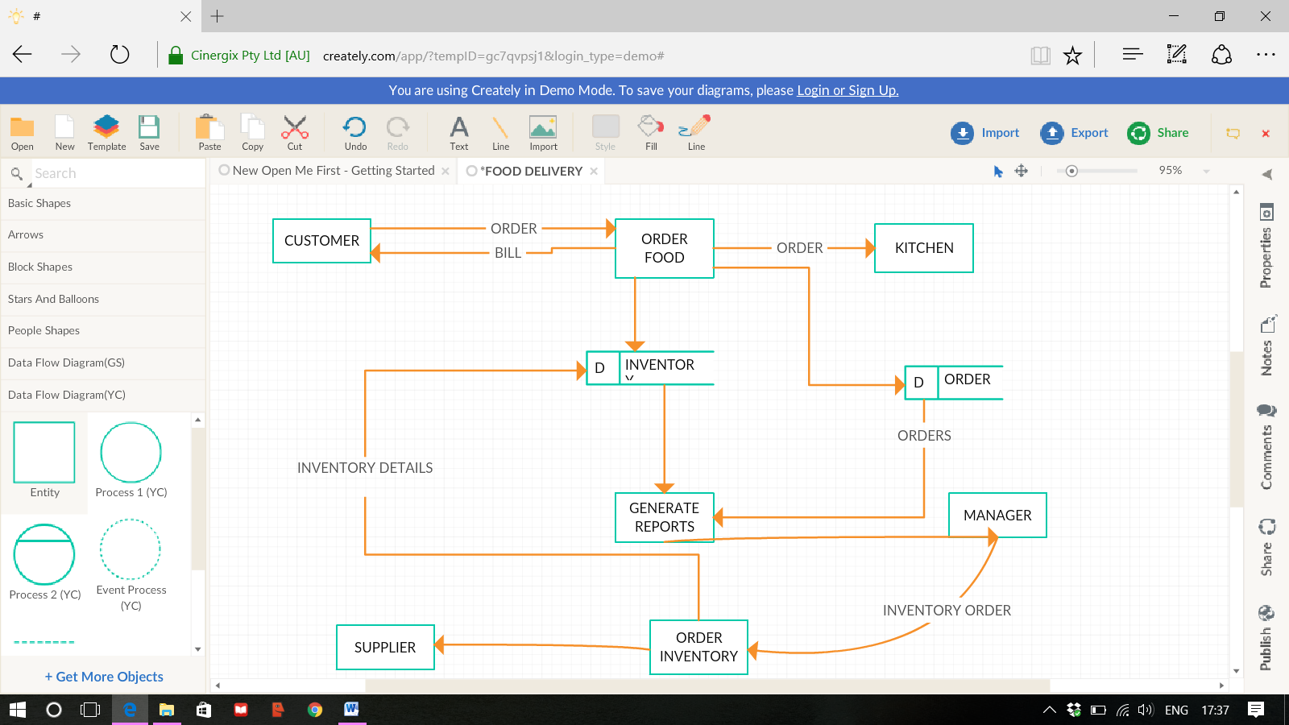

**MODULES:**

Users of the web ordering system, namely restaurant customers, must be provided the following functionality:

* Create an account.
* Manage their account.
* Log in to the system.
* Navigate the restaurant’s menu.
* Select an item from the menu.
* Customize options for a selected item.
* Add an item to their current order.
* Review their current order.
* Remove an item/remove all items from their current order.
* Provide delivery and payment details.
* Place an order.
* Receive confirmation in the form of an order number.

As the goal of the system is to make the process of placing an order as simple as possible for the customer, the functionality provided through the web ordering system is restricted to that which most pertinent to accomplish the desired task.

**SDLC Waterfall Model design**

Waterfall approach was first SDLC Model to be used widely in Software Engineering to ensure success of the project. In "The Waterfall" approach, the whole process of software development is divided into separate phases. In Waterfall model, typically, the outcome of one phase acts as the input for the next phase sequentially.

Following is a diagrammatic representation of different phases of waterfall model.

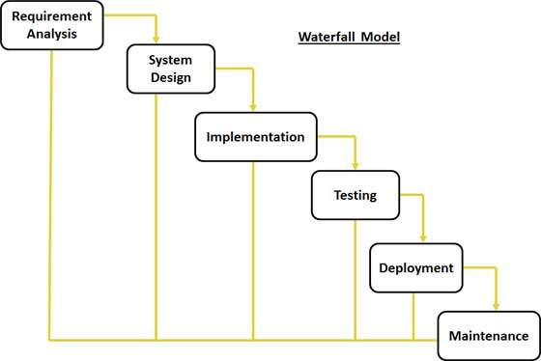

The sequential phases in Waterfall model are:

* **Requirement Gathering and analysis:** All possible requirements of the system to be developed are captured in this phase and documented in a requirement specification doc.
* **System Design:** The requirement specifications from first phase are studied in this phase and system design is prepared. System Design helps in specifying hardware and system requirements and also helps in defining overall system architecture.
* **Implementation:** With inputs from system design, the system is first developed in small programs called units, which are integrated in the next phase. Each unit is developed and tested for its functionality which is referred to as Unit Testing.
* **Integration and Testing:** All the units developed in the implementation phase are integrated into a system after testing of each unit. Post integration the entire system is tested for any faults and failures.
* **Deployment of system:** Once the functional and non functional testing is done, the product is deployed in the customer environment or released into the market.
* **Maintenance:** There are some issues which come up in the client environment. To fix those issues patches are released. Also to enhance the product some better versions are released. Maintenance is done to deliver these changes in the customer environment.

**FUNCTIONAL REQUIREMENTS:**

**UML DIAGRAMS:**

**ACTIVITY DIAGRAM:**

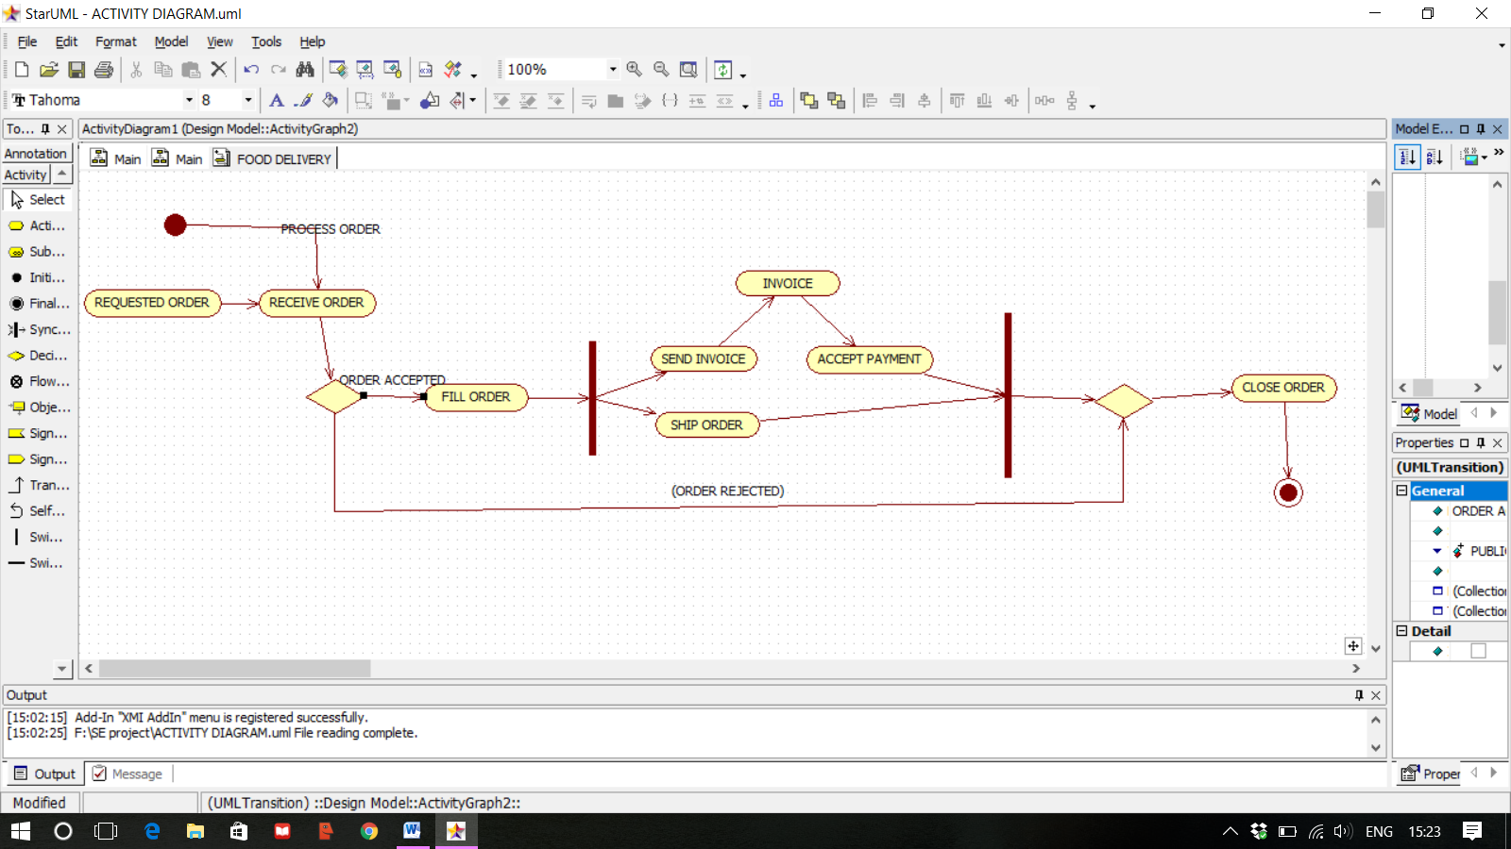

**CLASS DIAGRAM:**

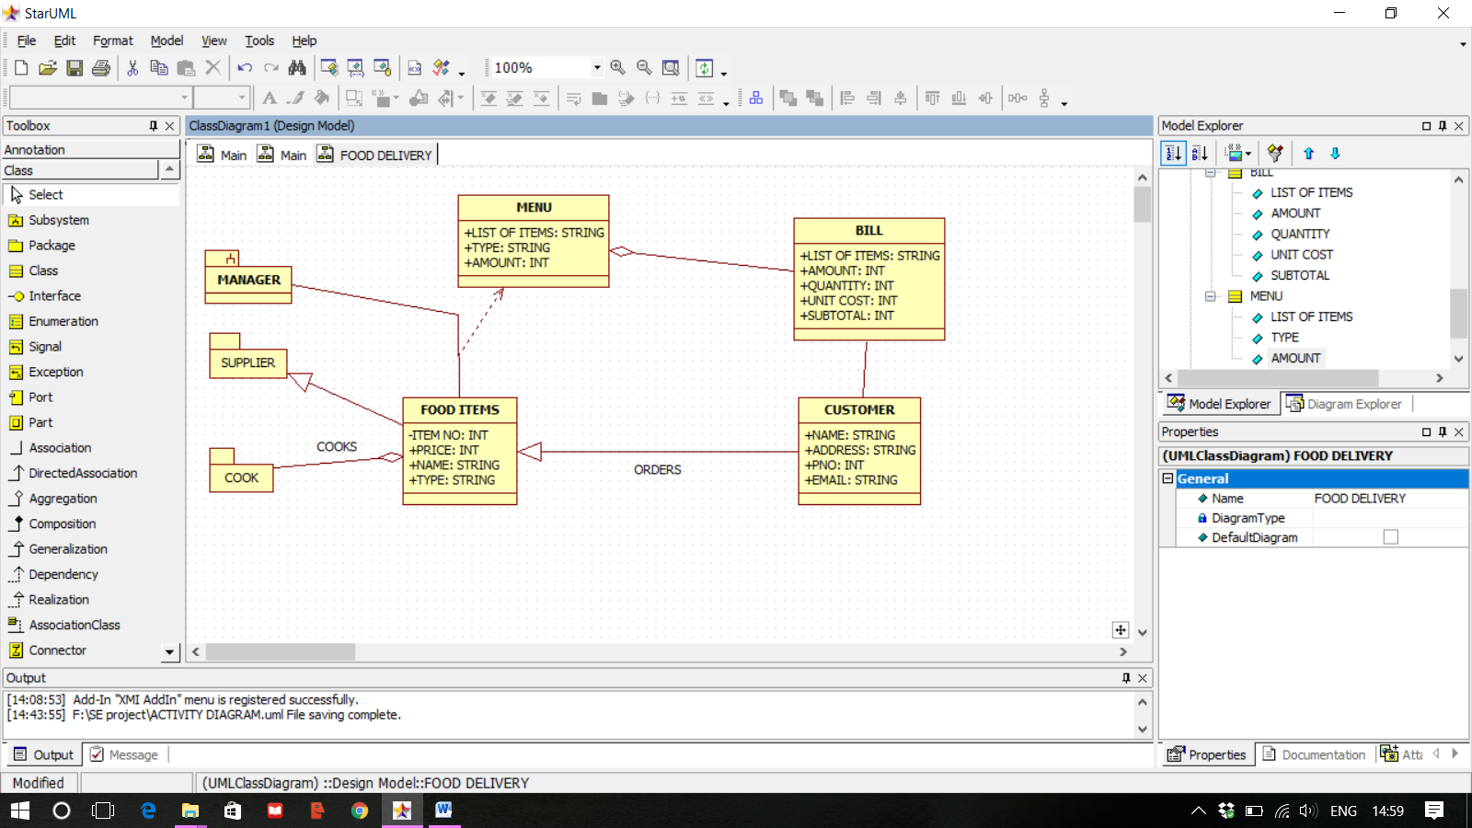

**USE CASE DIAGRAM:**

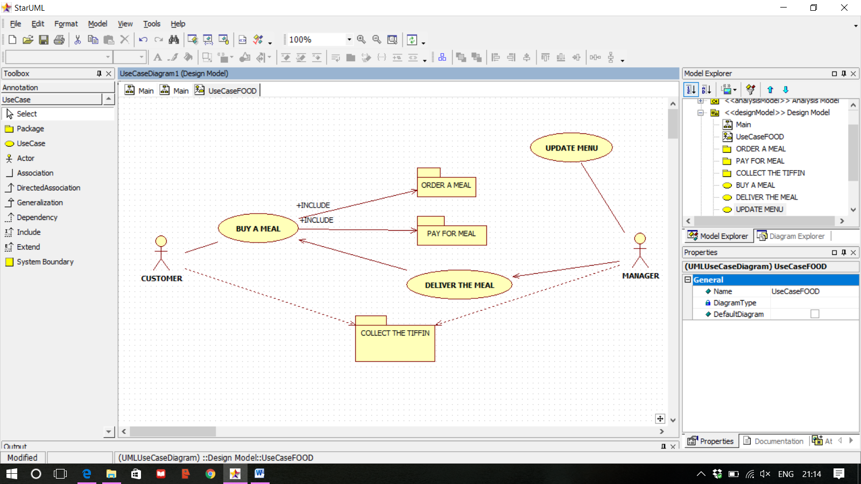

**Sequence diagram:**

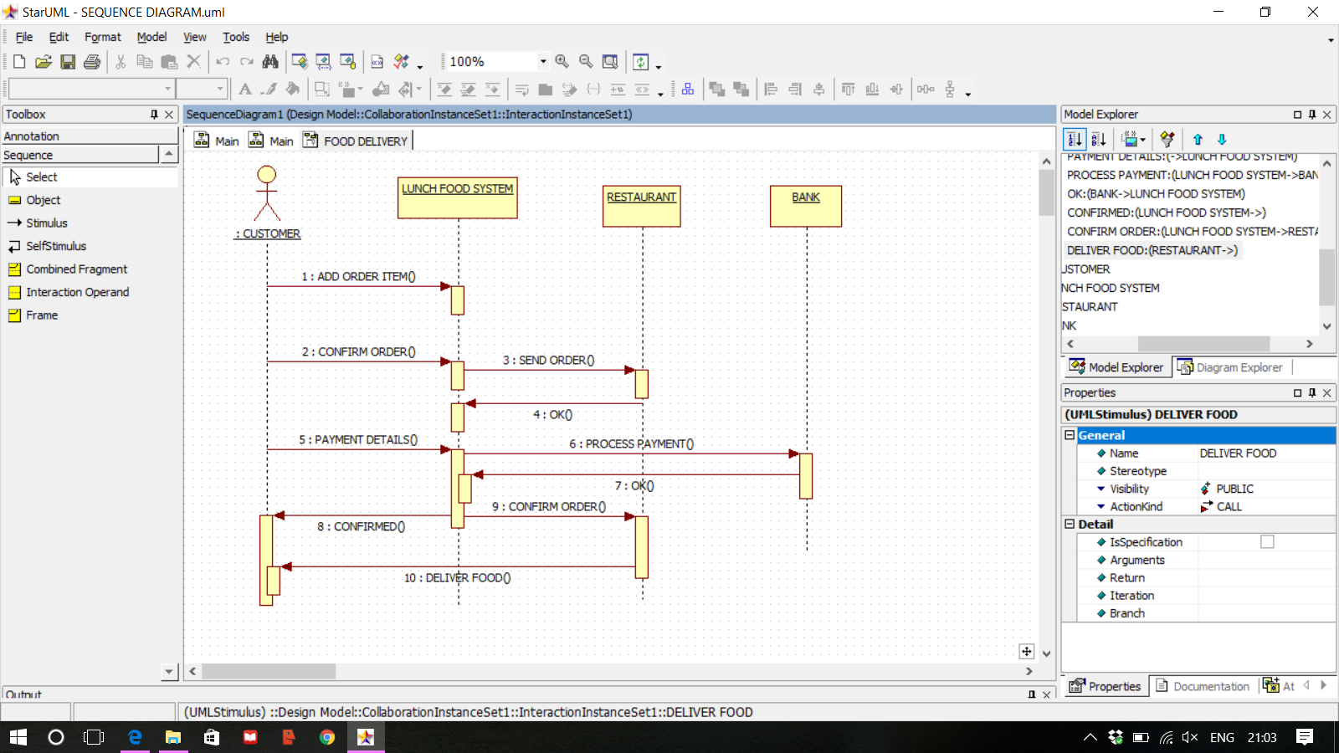

**DATABASE TABLE:**

|  |  |  |
| --- | --- | --- |
| ATTRIBUTES | DATATYPE | LENGTH |
| NAME | VARCHAR | 30 |
| CONTACT NO | INT | 10 |
| EMAIL | VARCHAR | NULL |
| QUANTITY | INT | 10 |
| DATE/TIME | DATE/TIME | - |
| ADDRESS | VARCHAR | 300 |
| MESSAGE | VARCHAR | 500 |

**SNAPSHOTS OF THE PROJECT:**

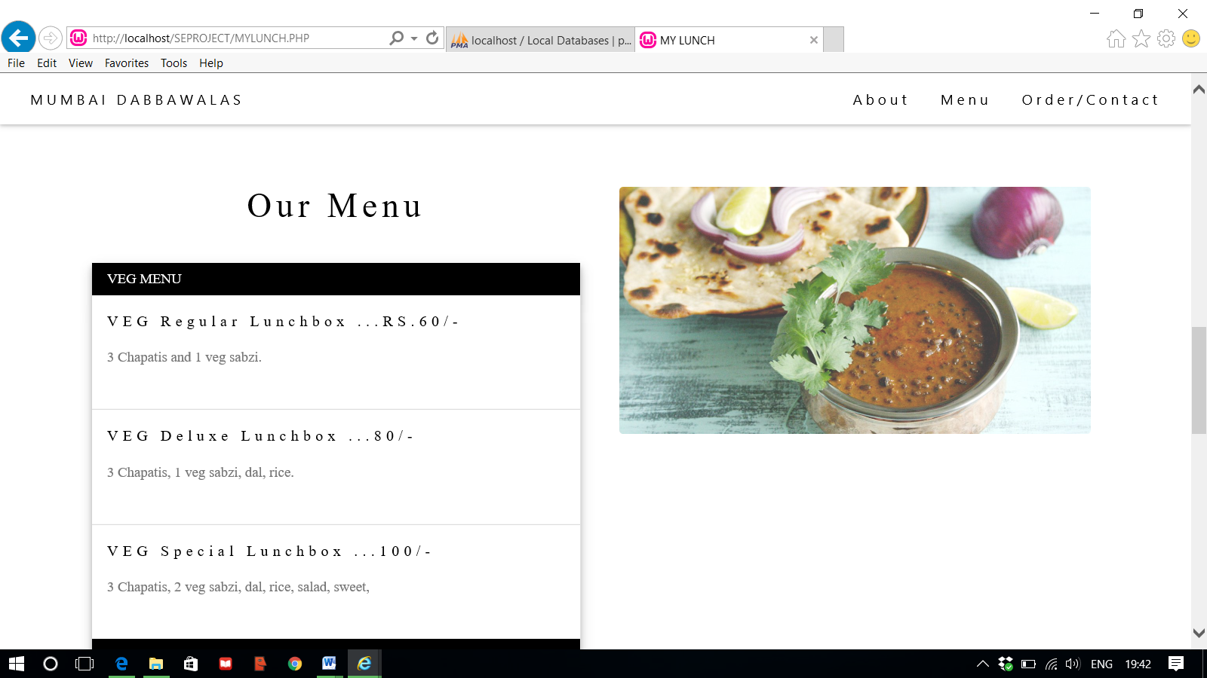

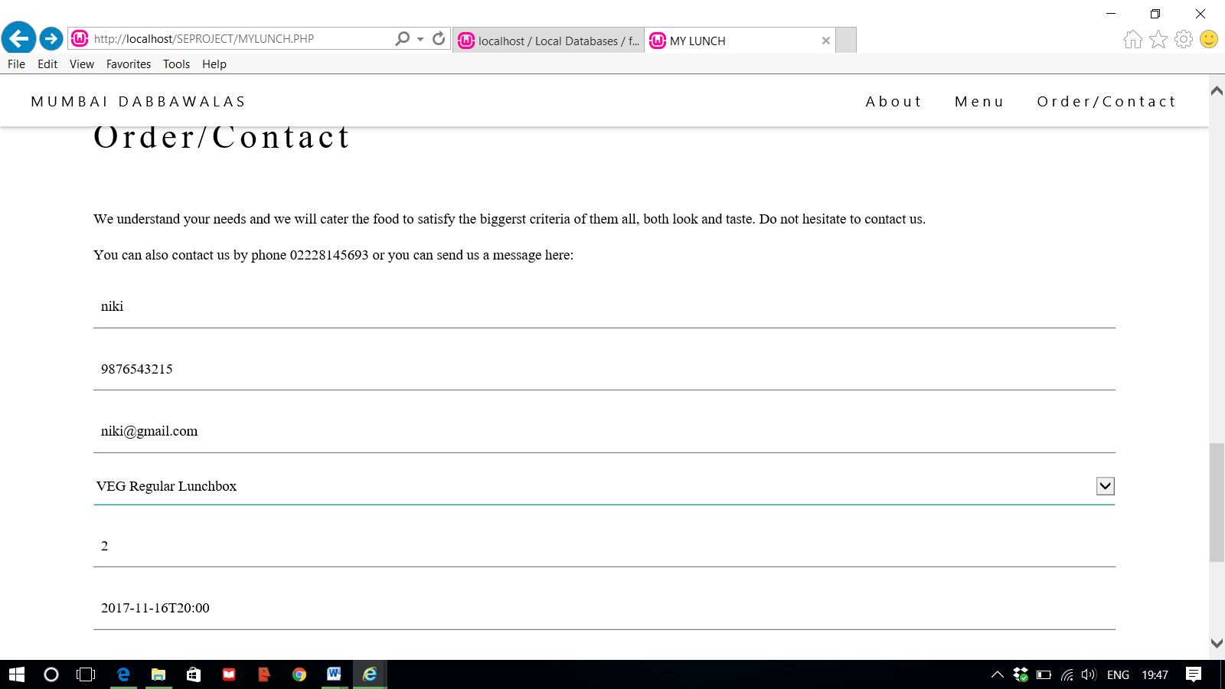

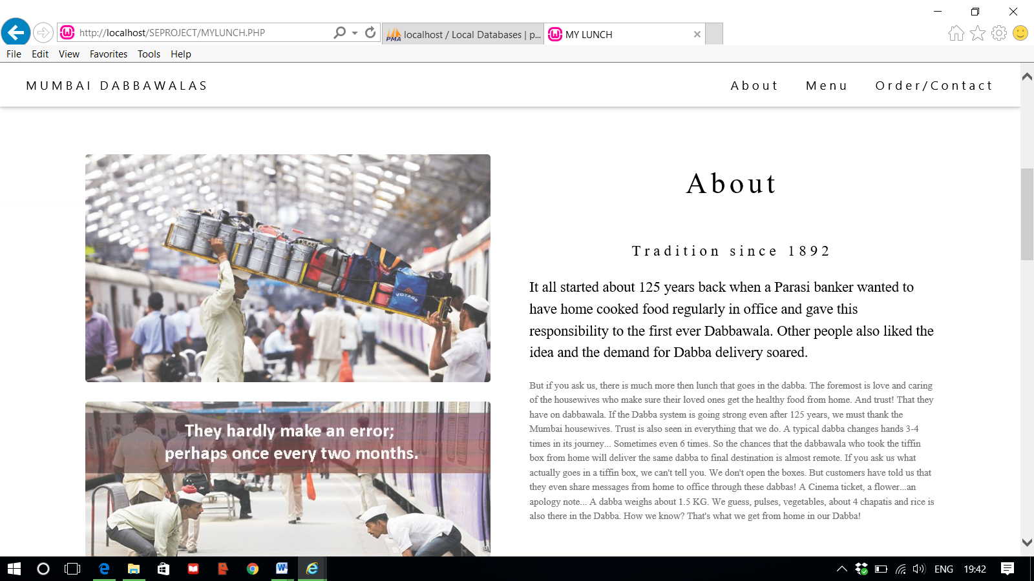

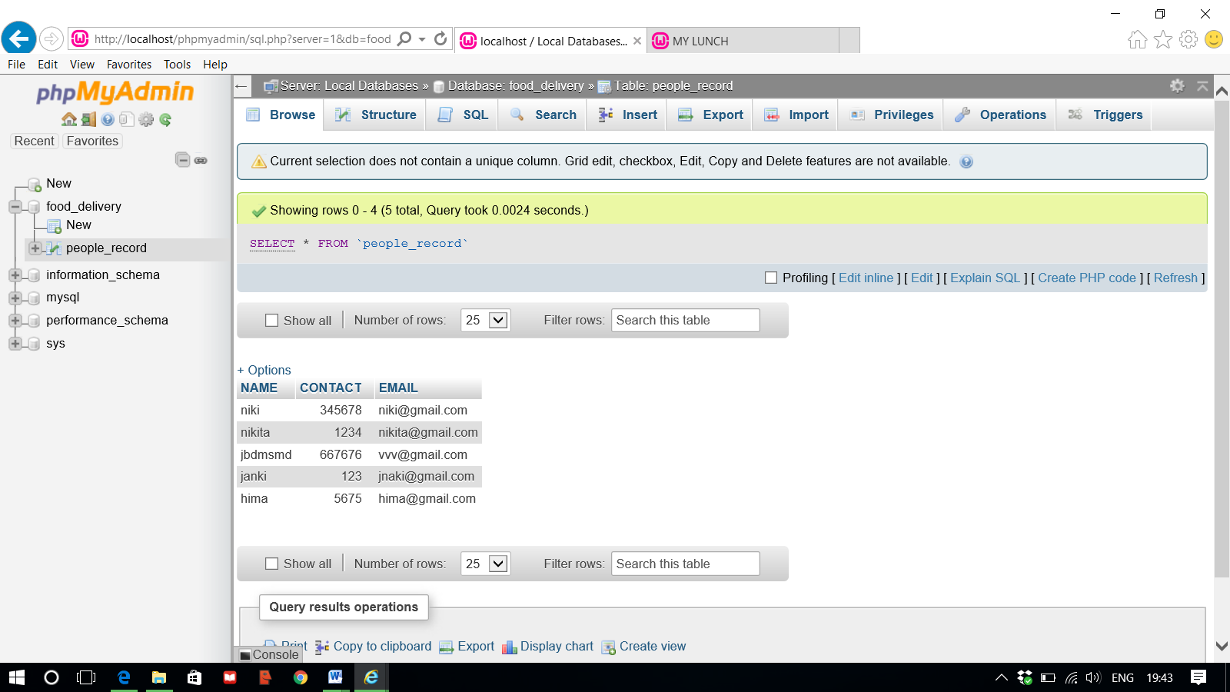

**CONCLUSION:**

Within this application, all items in the order are displayed, along with their corresponding options and delivery details, in a concise and easy to read manner. This allows restaurant employees to quickly go through the orders as they are placed and produce the necessary items with minimal delay and confusion.

Overall, we have created application in focus of future ONLINE FOOD ORDERING SYSTEMS, this application will be helpful to many people.

**REFERENCES:**

**-https://en.wikipedia.org/wiki/Online_food_ordering**

**-**https://www.w3schools.com/w3css/tryw3css_templates_gourmet_catering.htm

**-**https://www.scribd.com/doc/157447334/Online-Food-Ordering-System

**SAMPLE CODE :**

<?php

@mysql_connect('localhost','root','');

mysql_select_db('food_delivery');

if(isset($_POST['submit']))

{

$name= $_POST['name'];

$contact= $_POST['contact'];

$email= $_POST['email'];

mysql_query("insert into people_record values('$name','$contact','$email')");

}

?>

<!DOCTYPE html>

<html>

<title>MY LUNCH</title>

<meta charset="UTF-8">

<meta name="viewport" content="width=device-width, initial-scale=1">

<link rel="stylesheet" href="http://www.w3schools.com/lib/w3.css">

<style>

body {font-family: "Times New Roman", Georgia, Serif;}

h1,h2,h3,h4,h5,h6 {

font-family: "Playfair Display";

letter-spacing: 5px;

}

</style>

<body>

<!-- Navbar (sit on top) -->

<div class="w3-top">

<ul class="w3-navbar w3-white w3-wide w3-padding-8 w3-card-2">

<li>

<a href="#home" class="w3-margin-left">MUMBAI DABBAWALAS</a>

</li>

<!-- Right-sided navbar links. Hide them on small screens -->

<li class="w3-right w3-hide-small">

<a href="#about" class="w3-left">About</a>

<a href="#menu" class="w3-left">Menu</a>

<a href="#contact" class="w3-left w3-margin-right">Order/Contact</a>

</li>

</ul>

</div>

<!-- Header -->

<style>

.mySlides {display:none;}

</style>

<body>

<div class="w3-content w3-section" style="max-width:1000px;min-width:500px" id="home">

<img class="mySlides" src="C:\NIKKI\SE PROJECT\Mumbai-Dabbawalas.jpg" style="width:100%">

<img class="mySlides" src="C:\NIKKI\SE PROJECT\db2.jpg" style="width:100%" >

<img class="mySlides" src="C:\NIKKI\SE PROJECT\db3.jpg" style="width:100%">

</div>

<script>

var myIndex = 0;

carousel();

function carousel() {

var i;

var x = document.getElementsByClassName("mySlides");

for (i = 0; i < x.length; i++) {

x[i].style.display = "none";

}

myIndex++;

if (myIndex > x.length) {myIndex = 1}

x[myIndex-1].style.display = "block";

setTimeout(carousel, 2000); // Change image every 2 seconds

}

</script>

</body>

<!-- Page content -->

<div class="w3-content" style="max-width:1100px">

<!-- About Section -->

<div class="w3-row w3-padding-64" id="about">

<div class="w3-col m6 w3-padding-large w3-hide-small">

<img src="C:\NIKKI\SE PROJECT\dabba1.jpg" class="w3-round w3-image w3-opacity-min" alt="dabba1" width="600" height="750"><br><br>

<img src="C:\NIKKI\SE PROJECT\md.jpg" class="w3-round w3-image w3-opacity-min" alt="dabba1" width="600" height="750">

</div>

<div class="w3-col m6 w3-padding-large">

<h1 class="w3-center">About</h1><br>

<h5 class="w3-center">Tradition since 1892</h5>

<p class="w3-large">It all started about 125 years back when a Parasi banker wanted to have home cooked food regularly in office and gave this responsibility to the first ever Dabbawala. Other people also liked the idea and the demand for Dabba delivery soared.<br></p>

<p class="w3-small w3-text-grey" >But if you ask us, there is much more then lunch that goes in the dabba.

The foremost is love and caring of the housewives who make sure their loved ones get the healthy food from home.

And trust! That they have on dabbawala. If the Dabba system is going strong even after 125 years, we must thank the Mumbai housewives.

Trust is also seen in everything that we do. A typical dabba changes hands 3-4 times in its journey... Sometimes even 6 times. So the chances that the dabbawala who took the tiffin box from home will deliver the same dabba to final destination is almost remote.

If you ask us what actually goes in a tiffin box, we can't tell you. We don't open the boxes. But customers have told us that they even share messages from home to office through these dabbas! A Cinema ticket, a flower...an apology note...

A dabba weighs about 1.5 KG. We guess, pulses, vegetables, about 4 chapatis and rice is also there in the Dabba.

How we know? That's what we get from home in our Dabba!</p>

</div>

</div>

<hr>

<!-- Menu Section -->

<div class="w3-row w3-padding-16" id="menu">

<div class="w3-col l6 w3-padding-16">

<h1 class="w3-center">Our Menu</h1><br>

<div class="w3-container">

<div class="w3-accordion w3-card-4">

<button onclick="myFunction('Demo1')" class="w3-btn-block w3-left-align">

VEG MENU

</button>

<div id="Demo1" class="w3-accordion-content">

<ul class="w3-ul">

<li> <h6>VEG Regular Lunchbox ...RS.60/-</h6>

<p class="w3-text-grey">3 Chapatis and 1 veg sabzi.</p><br></li>

<li><h6>VEG Deluxe Lunchbox ...80/-</h6>

<p class="w3-text-grey">3 Chapatis, 1 veg sabzi, dal, rice.</p><br>

<li><h6>VEG Special Lunchbox ...100/-</h6>

<p class="w3-text-grey">3 Chapatis, 2 veg sabzi, dal, rice, salad, sweet, </p><br>

</li>

</ul>

</div>

<button onclick="myFunction('Demo2')" class="w3-btn-block w3-left-align">

NON-VEG MENU

</button>

<div id="Demo2" class="w3-accordion-content">

<ul class="w3-ul">

<li><h6>NON-VEG Regular Lunchbox ...70/-</h6>

<p class="w3-text-grey">3 Chapatis and 1 non-veg sabzi. </p><br></li>

</li>

<li><h6>NON-VEG Deluxe Lunchbox ...90/-</h6>

<p class="w3-text-grey">3 Chapatis, 1 non-veg sabzi, dal, rice.</p><br>

</li>

<li><h6>NON-VEG Special Lunchbox ...120/-</h6>

<p class="w3-text-grey">3 Chapatis, 2 non-veg sabzi, dal, rice, salad, sweet.</p><br>

</li>

</ul>

</div>

</div>

</div>

<script>

function myFunction(id) {

var x = document.getElementById(id);

if (x.className.indexOf("w3-show") == -1) {

x.className += " w3-show";

} else {

x.className = x.className.replace(" w3-show", "");

}

}

</script>

</div>

<div class="w3-center w3-padding-32">

<img src="C:\NIKKI\SE PROJECT\dabbawala.jpg" class="w3-round w3-image w3-opacity-min" alt="fooddaily" width="500" height="750">

</div>

</div>

<hr>

<!-- Contact Section -->

<div class="w3-container w3-padding-24" id="contact">

<h1>Order/Contact</h1><br>

<p>We understand your needs and we will cater the food to satisfy the biggerst criteria of them all, both look and taste. Do not hesitate to contact us.</p>

<p>You can also contact us by phone 02228145693 or you can send us a message here:</p>

<p><input class="w3-input w3-padding-16" type="text" placeholder="Name" required name="Name"></p>

<p><input class="w3-input w3-padding-16" type="text" placeholder="Contact No." required name="Contact No."></p>

<p><input class="w3-input w3-padding-16" type="email" placeholder="Email" required name="email"><p>

<p><select class="w3-select" placeholder="Select your dabba" required name="Select your dabba" >

<option value="1">VEG Regular Lunchbox</option>

<option value="2">NON-VEG Regular Lunchbox</option>

<option value="3">VEG Deluxe Lunchbox </option>

<option value="4">NON-VEG Deluxe Lunchbox </option>

<option value="5">VEG Special Lunchbox </option>

<option value="6">NON-VEG Special Lunchbox </option>

</select></p>

<p><input class="w3-input w3-padding-16" type="number" placeholder="Quantity" required name="Quantity"></p>

<p><input class="w3-input w3-padding-16" type="datetime-local" placeholder="Date and time" required name="date" value="2017-11-16T20:00"></p>

<p><input class="w3-input w3-padding-16" type="text" placeholder="Delivery Address (Office, workplace,etc)" required name="Delivery Address (Office, workplace,etc)"></p>

<p><input class="w3-input w3-padding-16" type="text" placeholder="Pickup Address" required name="Pickup Address"></p>

<p><input class="w3-input w3-padding-16" type="text" placeholder="Message \ Special requirements" name="Message"></p>

<p>

<button onclick="document.getElementById('id01').style.display='block'" class="w3-btn">SUBMIT</button>

<div id="id01" class="w3-modal">

<div class="w3-modal-content">

<div class="w3-container">

<span onclick="document.getElementById('id01').style.display='none'" class="w3-closebtn">&times;</span>

<p>THANKYOU FOR ORDERING !</p>

</div>

</div>

</div>

</form>

</div>

<!-- End page content -->

</div>

<!-- Footer -->

<footer class="w3-center w3-light-grey w3-padding-32">

<p>Presented by Nikita Mistry</p>

</footer>

</body>

</html>